Investigation 1: REACTION TIME

Do you have fast responses? During this investigation you will test the speed of your reactions. This plays a big role in your everyday life. Fast reaction times can produce big rewards, for example, like saving a blistering soccer ball from entering the goal. Slow reaction time has consequences. What is reaction time? It is a measure of how fast an organism can respond to a stimulus.

You also have reflexes. Reflexes and reactions, which at first may sound similar, are different from each other. All reflexes are involuntary actions, it protect the body and are very fast reactions. Reflexes are part of a negative feedback cycle and contribute to homeostasis. You know about the patellar reflex. So: is there a difference between a knee jerk and a good soccer player anxiously awaiting an oncoming soccer ball? Both are reflexes. But for a soccer player to decide how, when and if he is going to kick or dodge an oncoming soccer ball, thousands of neurons have to work together to produce a conscious decision. To take this decision, a reaction takes place.

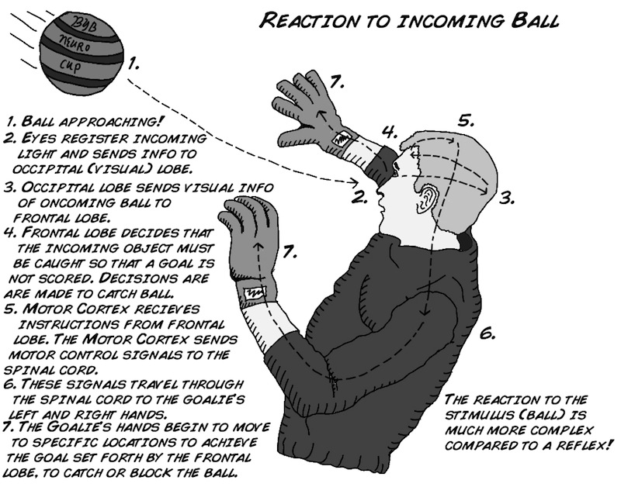
How does a soccer player know what to do? There is visual information that needs to be assessed and processed. The brain then needs to send many signals to various muscles. Feet begin to move, hands might travel in front of the face, and eyes may close shut, along with many more processes.

This is the work of many neurons as well as numerous systems and circuits in the brain, and what's more, and you can train and enhance your skill through practice.

This is how you get better at sports over time.

QUESTION 1
1.1 | Your friend must sit at a table with his/her dominant hand over the edge of the table.
1.2 | The first test is on visual response. You hold the ruler at the 30 cm mark in such a way that the 0 cm mark is nearest to your friend’s index finger.
1.3 | When you release the ruler, your friend needs to grab it as fast as he can. Ensure that you do not make any warning sound when releasing the ruler. Record the cm mark where the ruler was grabbed. Your friend is now reacting on the visual stimulus: as soon as he sees the ruler being released, he needs to react on it.
1.4 | Repeat this procedure three times. Switch places with your partner and redo the whole exercise.
1.5 | Switch places with your partner and do the exercise again. Blindfold your partner. This time, say the word “NOW!” when you release the ruler. Record the cm mark where the ruler was grabbed. Your friend is now reacting on the auditory stimulus: as soon as he hears the ruler being released, he reacts to it. Repeat it three times, recording it. Switch places with your partner.
1.6 | For the last time, switch places with your partner and do the exercise again. Blindfold your partner. This time, you touch his / her shoulder when you release the ruler. Record the cm mark where the ruler was grabbed. Your friend is now reacting on the tactile stimulus: as soon as he feels your touch, he reacts to it. Repeat it three times, recording it. Switch places with your partner.
1.7 | Complete the table.
 | Table showing the grab distance in cm for two persons with the visual, auditory and tactile stimuli.
 | Visual Stimulus  (in cm) | Auditory Stimulus  (in cm) | Tactile Stimulus  (in cm)
Person #1
Person #2

1.8 | The following table was completed by Anne and Mary.
 | Table showing the grab distance in cm for Anne and Mary with the visual, auditory and tactile stimuli.
 | Visual Stimulus  (in cm) | Auditory Stimulus  (in cm) | Tactile Stimulus  (in cm)
Anne | 29.5 | 15.5 | 11.5
Anne | 30.0 | 17.0 | 13.0
Anne | 29.0 | 16.5 | 12.0
Mary | 30.0 | 14.5 | 12.5
Mary | 30.0 | 16.5 | 10.5
Mary | 29.5 | 19.0 | 11.0

QUESTION 2
2.1 | Calculate the average (y) for Anne’s and Mary’s responses respectively. Show all calculations. | (3)
 | ______________________________________________________________________________________________________________________________________________________________________________________________________________________________________________________________________________________________________________________________________________________________________________________________________________________________________________________________________________________________________________________________________________________________________________________________________________
2.2 | To calculate the average response time (in seconds), the average gravitational acceleration needs to be considered. The average gravitational acceleration (g₀) is 9,81m/s². The readings used in QUESTION 1.8, were in cm. The y-value represents the average response that was calculated in QUESTION 2.1. Therefore the gravitational acceleration is taken as 981cm/s². Use the following formula and determine the average response times for both Anne and Mary for each stimulus. Show all calculations.
Formula:
NOTE: the y-value was calculated in QUESTION 2.1
Response time = $\sqrt{\frac{2 y cm}{981 cm/s^{2}}}$
 | _________________________________________________________________________________________________________________________________________________________________________________________________________________________________________________________________________________________________________________________________________________________________________________________________________________________________________________________________________________________________________________________________________________________________________________________________________________________________________________________________________________________________________________________________________________________________________________________________________________________________________________________________________________________________________________________________________________________________________________________________________________________________________________________________________________________________________________________________________________________________________________________________________________________________________________________________________________________________________________________________________________________________________________________________________________________________________________________________________________________________________________________________________________________________________________________________________________-_______________________________________ | (4)
2.3 | Write down two constant variables to be used during this experiment. | (2)
___________________________________________________________
___________________________________________________________

2.4 | Why was the test person blindfolded?  ___________________________________________________________  ___________________________________________________________ | (2)
2.5 | Draw a bar graph to indicate the average reaction time of different stimuli graphically. Use Anne’s and Mary’s information on the same set of axis. | (5)
2.6 | Is this experiment reliable? Give a reason for your answer. | (2)
___________________________________________________________
___________________________________________________________
2.7 | What are two possible problems in your experimental design or the way it was carried out? | (2)
___________________________________________________________
___________________________________________________________
2.8 | How will these results influence your decisions regarding the environment in which you study?
 | ___________________________________________________________ | (1)
2.9 | Do you think that reaction time can be improved? Explain your answer.
 | ___________________________________________________________  ___________________________________________________________ | (2)
2.10 | What implication do these results have on driving? (What will be the safest and the most dangerous thing to do during driving?) Motivate your answer.
 | ___________________________________________________________  ___________________________________________________________  ___________________________________________________________ | (3)
2.11 | Why is the tactile reaction time higher than the visual reaction time?
 | _________________________________________________________________________________________________________________________________________________________________________________ | (2)

